# Database Basics MS SQL Exam – 29 Aug 2018

Exam problems for the [“Database Basics” course @ SoftUni](https://softuni.bg/courses/databases-basics-ms-sql-server).

Submit your solutions in the SoftUni Judge system at <https://judge.softuni.bg/>

# Supermarket

After feeling extremely disappointed with your previous job at “**Krivodol Trip Service LLC**”, you have now started working for a new and much better company– “**Pustinqk Software**”. From the very beginning your new boss saw a huge potential in you and has assigned you a very exciting project. In **6 hours**, you must develop a complicated system for a small shop, which has now grown bigger.

# Your database must contain information about the employees and their work hours. You must also include information about the products and their orders.

# Section 1. DDL (30 pts)

You are given an E/R Diagram of the Trip Service:

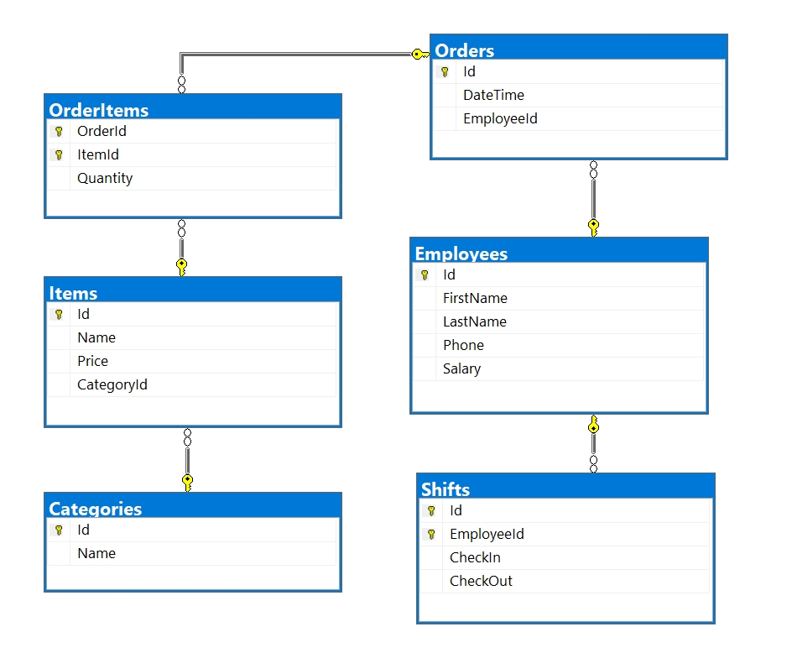

Crеate a database called **Supermarket**. You need to create **6 tables**:

* **Categories** – contains information about the **item** **categories**.
* Items – contains information about the items and their categories.
* Orders – contains information about all of the store orders.
* OrderItems – contains information about every order’s items.
* Employees – contains information about the employees.
* Shifts – contains information about **check-in** tracking for **employees**.

### Categories

|  |  |  |
| --- | --- | --- |
| **Column** | **Data Type** | **Constraints** |
| Id | **Integer** from **0** to **2,147,483,647** | Unique table **identificator**, **Identity** |
| Name | **String** up to 30 symbols, Unicode | **NULL** is **not** allowed |

### Items

|  |  |  |
| --- | --- | --- |
| **Column** | **Data Type** | **Constraints** |
| Id | **Integer** from **0** to **2,147,483,647** | Unique table **identificator**, **Identity** |
| Name | **String** up to 30 symbols, Unicode | **NULL** is **not** allowed |
| Price | **Decimal** number with **two-digit** precision | **NULL** is **not** allowed |
| CategoryId | **Integer** from **0** to **2,147,483,647** | **NULL** is **not** allowed, Relationship with table Categories |

### Employees

|  |  |  |
| --- | --- | --- |
| **Column** | **Data Type** | **Constraints** |
| Id | **Integer** from **0** to **2,147,483,647** | Unique table **identificator**, **Identity** |
| FirstName | **String** up to 50 symbols, Unicode | **NULL** is **not** allowed |
| LastName | **String** up to 50 symbols, Unicode | **NULL** is **not** allowed |
| Phone | **String** with **exactly 12** symbols | **NULL** is **not** allowed |
| Salary | **Decimal** number with **two-digit** precision | **NULL** is **not** allowed |

### Orders

|  |  |  |
| --- | --- | --- |
| **Column** | **Data Type** | **Constraints** |
| Id | **Integer** from **0** to **2,147,483,647** | Unique table **identificator**, **Identity** |
| DateTime | **DateTime** | **NULL** is **not** allowed |
| EmployeeId | **Integer** from **0** to **2,147,483,647** | **NULL** is **not** allowed, Relationship with table Employees |

### OrderItems

|  |  |  |
| --- | --- | --- |
| **Column** | **Data Type** | **Constraints** |
| OrderId | **Integer** from **0** to **2,147,483,647** | **NULL** is **not** allowed, Relationship with table **Orders** |
| ItemId | **Integer** from **0** to **2,147,483,647** | **NULL** is **not** allowed, Relationship with table **Items** |
| Quantity | **Integer** from **0** to **2,147,483,647** | **NULL** is **not** allowed, must be **at least 1** |

### Shifts

|  |  |  |
| --- | --- | --- |
| **Column** | **Data Type** | **Constraints** |
| Id | **Integer** from **0** to **2,147,483,647** | Unique table **identificator**, **Identity** |
| EmployeeId | **Integer** from **0** to **2,147,483,647** | Unique table **identificator** , Relationship with table **Employees** |
| CheckIn | **DateTime** | **NULL** is **not** allowed |
| CheckOut | **DateTime** | **NULL** is **not** allowed, must be after CheckIn date |

## Database Design

Submit all of yours **create** **statements** to the **Judge** system.

# Section 2. DML (10 pts)

**Before you start, you must import “**DataSet-Supermarket.sql**”. If you have created the structure correctly, the data should be successfully inserted without any errors.**

In this section, you have to do some data manipulations:

## Insert

**Insert** some sample data into the database. Write a query to add the following records into the corresponding tables. **All Ids should be auto-generated**.

**Employees**

|  |  |  |  |
| --- | --- | --- | --- |
| **FirstName** | **LastName** | **Phone** | **Salary** |
| Stoyan | Petrov | 888-785-8573 | 500.25 |
| Stamat | Nikolov | 789-613-1122 | 999995.25 |
| Evgeni | Petkov | 645-369-9517 | 1234.51 |
| Krasimir | Vidolov | 321-471-9982 | 50.25 |

**Items**

|  |  |  |
| --- | --- | --- |
| **Name** | **Price** | **CategoryId** |
| Tesla battery | 154.25 | 8 |
| Chess | 30.25 | 8 |
| Juice | 5.32 | 1 |
| Glasses | 10 | 8 |
| Bottle of water | 1 | 1 |

## Update

Make all items’ prices **27% more expensive** where the **category ID** is either **1**, **2** or **3.**

## Delete

Delete all order items where the order id is 48 (be careful with the relationships)

# Section 3. Querying (40 pts)

**You need to start with a fresh dataset, so recreate your DB and import the sample data again (**DataSet-Supermarket.sql**).**

## Richest People

Select all **employees** who have a **salary** above **6500**. Order them by **first name**, then by **employee** **id**.

### Example

|  |  |
| --- | --- |
| **Id** | **FirstName** |
| 19 | Arney |
| 32 | Arther |
| 2 | Celie |
| 11 | Emlynn |
| … | … |

## Cool Phone Numbers

Select all **full names** from employees,whose phone number start with ‘**3**’.

Order them by **first name** **(ascending)**, then by phone number **(ascending)**.

### Example

|  |  |
| --- | --- |
| **Full Name** | **Phone Number** |
| Adolphe Leacock | 339-446-1263 |
| Audie Risebarer | 341-873-1275 |
| Demeter Langdale | 312-175-3209 |
| Jordanna Asmus | 323-785-5898 |
| … | … |

## Employee Statistics

Select all **employees** who have orders with the total count of the orders they processed. Order them by their **orders count (descending)**, then by **first name**. Select their **first name**, **last name** and **total count** of **orders**.

### Example

|  |  |  |
| --- | --- | --- |
| **FirstName** | **LastName** | **Count** |
| Bart | Jozwiak | 123 |
| Beverlee | Raveau | 116 |
| Ashley | Topliss | 106 |
| Gayler | Wike | 103 |
| Celie | De Cruce | 96 |
| … | … | … |

## Hard Workers Club

Select all **employees** whose workday is **over 7 hours long on average**, based on their **check in/check out times**. Select their **first, last name** and **average** **work hours**.

Order them by **work hours** **(descending),** then by **employee ID**.

### Example

|  |  |  |
| --- | --- | --- |
| **FirstName** | **LastName** | **Work hours** |
| Gill | Wasiela | 9 |
| Celie | De Cruce | 8 |
| Jordanna | Asmus | 8 |
| Lucie | Dickinson | 8 |
| … | … | ... |

## The Most Expensive Order

Find the most expensive order. Select its **id** and total item price. Consider the item **quantity** when calculating the price.

### Example

|  |  |
| --- | --- |
| **OrderId** | **TotalPrice** |
| 479 | 14087.84 |

## Rich Item, Poor Item

Find the top 10 **most expensive** and **cheapest** item in **each order.**

Order the results by **most expensive item’s price** (**descending),** then by order id (**ascending**)**.**

### Example

|  |  |  |
| --- | --- | --- |
| **OrderId** | **ExpensivePrice** | **CheapPrice** |
| 1 | 360.00 | 3.14 |
| 6 | 360.00 | 1.50 |
| 10 | 360.00 | 1.23 |
| 39 | 360.00 | 2.00 |
| … | … |  |

## Cashiers

Find all employees who have orders. Select their id, first name and last name. Order them by **employee id**.

### Example

|  |  |  |
| --- | --- | --- |
| **Id** | **First Name** | **Last Name** |
| 2 | Celie | De Cruce |
| 5 | Lucie | Dickinson |
| 8 | Adaline | Gilogly |
| … | … | … |

## Lazy Employees

Find all employees, who have below 4 work hours per day.

Order them by employee id.

### Example

|  |  |
| --- | --- |
| **Id** | **Full Name** |
| 1 | Krishnah Lalor |
| 4 | Jasmine Forsdike |
| 7 | Ole De la Feld |
| … | … |

## Sellers

Find the top 10 employees with their full name, orders’ total price and item count.

Count only orders which were **ordered** **before 2018-06-15**.

Order them by **total sum (descending)**, then by **item count (descending)**

### Example

|  |  |  |
| --- | --- | --- |
| **Full Name** | **Total Price** | **Items** |
| Bart Jozwiak | 37612.33 | 2497 |
| Adaline Gilogly | 26989.77 | 1765 |
| Celie De Cruce | 25692.80 | 1773 |
| Gayler Wike | 24754.87 | 2350 |
| Lucie Dickinson | 23707.26 | 1223 |
| … | … | … |

## Tough days

Find all records of the employees who don’t have orders and who work over 12 hours.

Select only their full name and day of the week.

Order the results by **employee id**.

**Note: By the American Standards, Sunday is the first day of week.**

### Example

|  |  |
| --- | --- |
| **Full Name** | **Day of week** |
| Krishnah Lalor | Sunday |
| Jordanna Asmus | Monday |
| Ole De la Feld | Friday |
| Ole De la Feld | Thursday |
| … | … |

## Top Order per Employee

Find all information of the employees who have orders. Select their full name, duration of the work day (**in hours**) and total price of all sold products. Find only the **top orders** (top orders with highest total price).

Sort them by **full name** (ascending), **work hours** (descending) and **total price** (descending)

### Example

|  |  |  |
| --- | --- | --- |
| **Full Name** | **WorkHours** | **TotalPrice** |
| Adaline Gilogly | 5 | 9460.00 |
| Adolphe Leacock | 5 | 14087.84 |
| Anatola Lydon | 8 | 4090.80 |
| … | … | … |

## Average Profit per Day

Find the **average** **profit** for each day. Select the **day of month** and **average daily profit** of sold products.

Sort them by **day of month** (ascending) and format the profit to the **second digit** after the decimal point.

### Example

|  |  |
| --- | --- |
| **Day** | **Total profit** |
| 1 | 254.79 |
| 3 | 211.49 |
| 4 | 115.89 |
| 5 | 83.26 |
| 6 | 111.47 |
| 7 | 101.49 |
| 8 | 140.65 |
| 10 | 90.17 |
| 11 | 281.59 |
| 12 | 162.31 |
| 13 | 127.65 |
| … | … |

## Top Products

Find information about **all products**. Select their name, category, how many of them were sold and the total profit they produced.

Sort them by **total profit** (**descending**) and **their count** (**descending**)

### Example

|  |  |  |  |
| --- | --- | --- | --- |
| **Item** | **Category** | **Count** | **TotalPrice** |
| TV | Miscellaneous | 308 | 110880.00 |
| Tires | Miscellaneous | 524 | 78600.00 |
| Mattress | Miscellaneous | 298 | 29800.00 |
| Camera | Miscellaneous | 352 | 28160.00 |
| … | … | … | … |

# Section 4. Programmability (20 pts)

## Promotion days

Create a **user defined function**, named **udf_GetPromotedProducts(@CurrentDate, @StartDate, @EndDate, @Discount, @FirstItemId, @SecondItemId, @ThirdItemId)**, that receives a **current date**, a **start date** for the promotion, an **end date** for the promotion, a **discount**, a **first item id**, a **second item id** and **third item id**.

The function should print the discounted price of the items, based on these conditions:

* The first, second and third items must exist in the database.
* The current date must be between the start date and end date.

If both conditions are true, you must discount the price and print the following message in the format:

* “**{FirstItemName} price: {@FirstItemPrice} <-> {SecondItemName} price: {@SecondItemPrice} <-> {ThirdItemName} price: {@ThirdItemPrice}**”

If one of the items is not in the database, the function should return “One of the items does not exists!”  
If the current date is not between the start date and end date, the function should return “The current date is not within the promotion dates!”

**Note: Do not update any records in the database!**

### Example:

|  |
| --- |
| **Query** |
| **SELECT dbo.udf_GetPromotedProducts('2018-08-02', '2018-08-01', '2018-08-03',13, 3,4,5)** |
| **Output** |
| **Water price: 0.74 <-> Juice price: 1.31 <-> Ayran price: 4.35** |

|  |
| --- |
| **Query** |
| **SELECT dbo.udf_GetPromotedProducts('2018-08-01', '2018-08-02', '2018-08-03',13,3 ,4,5)** |
| **Output** |
| The current date is not within the promotion dates! |

## Cancel order

Create a **user defined stored procedure**, named **usp_CancelOrder(@OrderId, @CancelDate)**, that receives an **order id** and **date**, and attempts to **delete the current order**. An order will only be deleted if all of these conditions **pass**:

* If the **order** doesn’t exists, then it **cannot be deleted.** **Raise an error** with the message “The order does not exist!”
* If the **cancel date** is 3 days after the issue date, **raise an error** with the message “You cannot cancel the order!”

If all the above conditions pass, **delete the order**.

### Example usage:

|  |  |
| --- | --- |
| **Query** | **Output** |
| **EXEC usp_CancelOrder 1, '2018-06-02'**  **SELECT COUNT(*) FROM Orders**  **SELECT COUNT(*) FROM OrderItems** | **998**  **2455** |
| **EXEC usp_CancelOrder 1, '2018-06-15'** | **You cannot cancel the order!** |
| **EXEC usp_CancelOrder 124231, '2018-06-15'** | **The order does not exist!** |

## Deleted Order

Create a new table **“DeletedOrders**” with columns **(OrderId, ItemId, ItemQuantity)**. Create a **trigger**, which fires when order is deleted. After deleting the order, **insert all of the data into the new table “DeletedOrders”**.

Note: Submit only your **CREATE TRIGGER** statement!

### Example usage:

|  |
| --- |
| **Query** |
| **DELETE FROM OrderItems**  **WHERE OrderId = 5**  **DELETE FROM Orders**  **WHERE Id = 5** |
| **Response** |
| **(5 rows affected)**  **(5 rows affected)**  **(1 rows affected)** |